**LAPORAN TUGAS**

**MATA KULIAH PRAKTIKUM BASIS DATA**

Dosen Pengampu : Farid Angga Pribadi, S.Kom, M.Kom.

**PERTEMUAN - 10**



**Nama : M. Zidna Billah Faza**

**NIM : 2341760030**

**Prodi : D-IV Sistem Informasi Bisnis**

**JURUSAN TEKNOLOGI INFORMASI**

**POLITEKNIK NEGERI MALANG**

**2024**

**Langkah 1**

mysql -u root -p

**Langkah 2**

create database Data_Pegawai;

**Langkah 3**

use Data_Pegawai;

**Langkah 4**

create table golongan (

golongan varchar (1) not null primary key,

besar_gaji varchar(10) not null);

**Langkah 5**

create table proyek (

no_proyek varchar (10) not null primary key,

nama_proyek varchar (10) not null,

constraint no_proyek_format check (no_proyek like 'NP%'));

**Langkah 6**

create table pegawai (

no_pegawai varchar (10) not null primary key,

nama_pegawai varchar (50) not null,

golongan varchar (1) not null,

constraint no_pegawai_format check (no_pegawai like 'Peg%'),

foreign key (golongan) references golongan(golongan));

**Langkah 7**

create table proyek_pegawai (

no_proyek varchar (10) not null,

no_pegawai varchar (10) not null,

foreign key (no_proyek) references proyek(no_proyek),

foreign key (no_pegawai) references pegawai(no_pegawai));

**Langkah 8**

insert into golongan(golongan, besar_gaji)

-> value

-> ('A', '1.000.000'),

-> ('B', '900.000'),

-> ('C', '750.000');

**Langkah 9**

insert into proyek(no_proyek, nama_proyek)

-> value

-> ('NP001', 'BRR'),

-> ('NP002', 'PEMDA');

**Langkah 10**

insert into pegawai(no_pegawai, nama_pegawai, golongan)

-> value

-> ('Peg12', 'Sita', 'B'),

-> ('Peg14', 'Yusni', 'B');

**Langkah 11**

insert into proyek_pegawai(no_proyek, no_pegawai)

-> value

-> ('NP001', 'Peg01'),

-> ('NP001', 'Peg02'),

-> ('NP001', 'Peg06'),

-> ('NP002', 'Peg12'),

-> ('NP002', 'Peg14');

**Hasil**

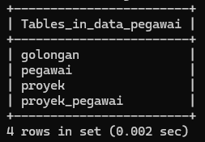

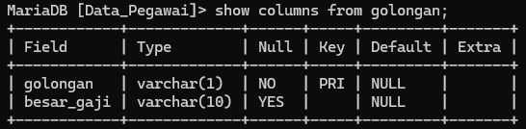

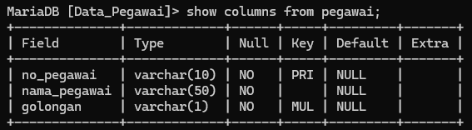

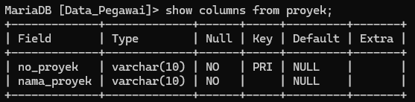

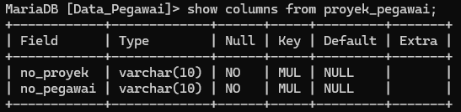

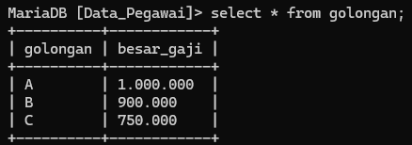

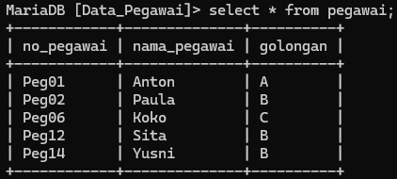

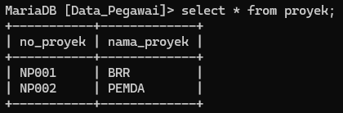

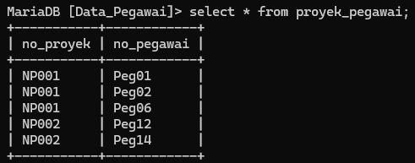

File pdf berada pada link berikut :

<https://drive.google.com/drive/folders/1E3zXEMCiVwyFX_TAp2zCI40Y-TgohL-b?usp=sharing>